Character Device driver development:

When you use an open system call on the device file, how does the kernel connects the open system call to the intended drivers open method?
To establish the connection the kernel uses Device number (4:0, 4:1, 4:2, 4:3) of that file.
Here 4 is major number and 0 to 3 is minor number, Minor number is also called as instance
VFS get the device number from driver registration list. The driver has to be registered with the VFS so that VFS can find a correct driver and forward the user level request to driver’s method.

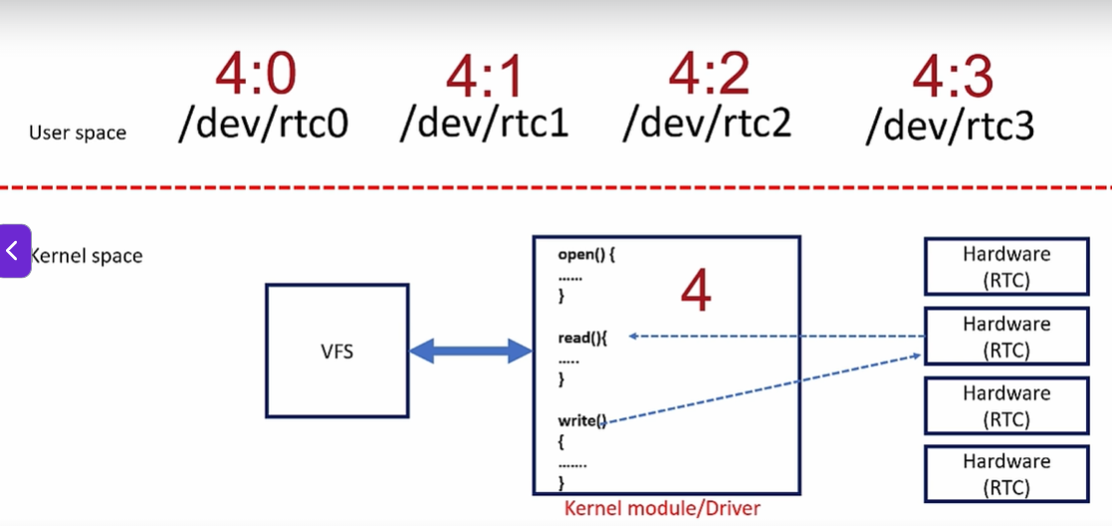

How when we use open system call for a device file then it recognize that whicg function should call.
When we call open system call from user space then VFS search for major and minor file number
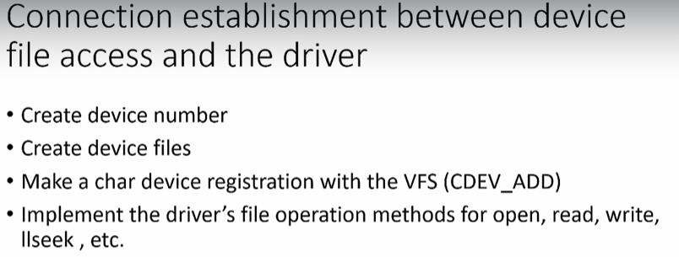

Create device number
- Ask the kernel to dynamically allocate the device number(s)
Kernel APIs and utilities to be used in driver code

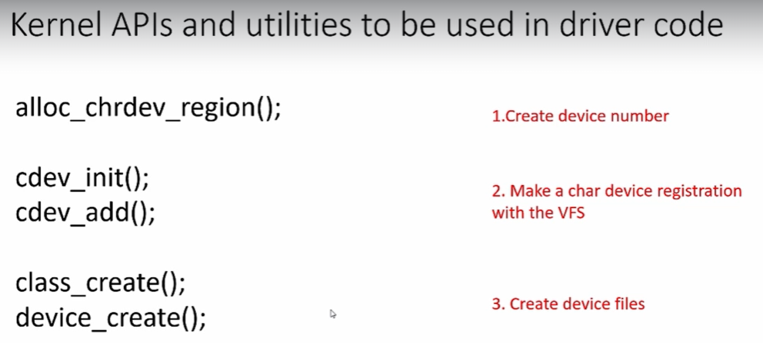

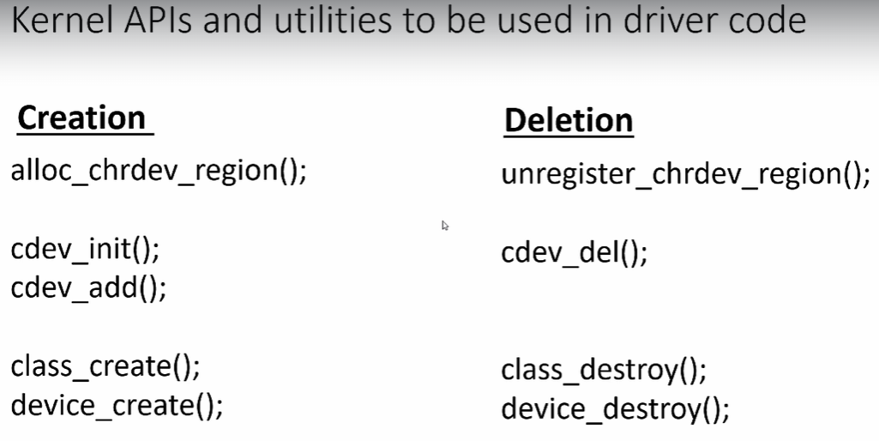
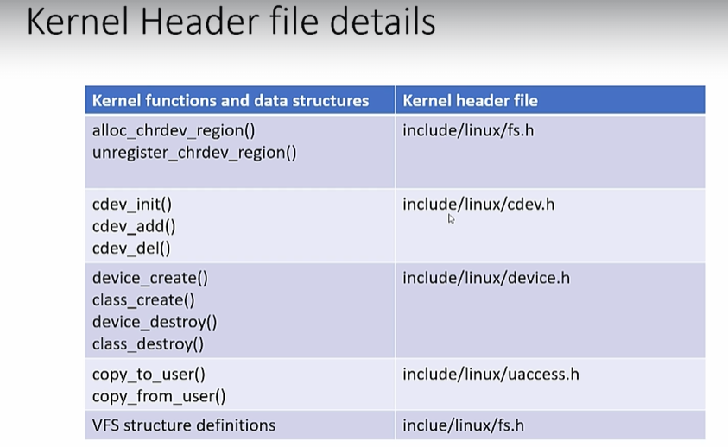

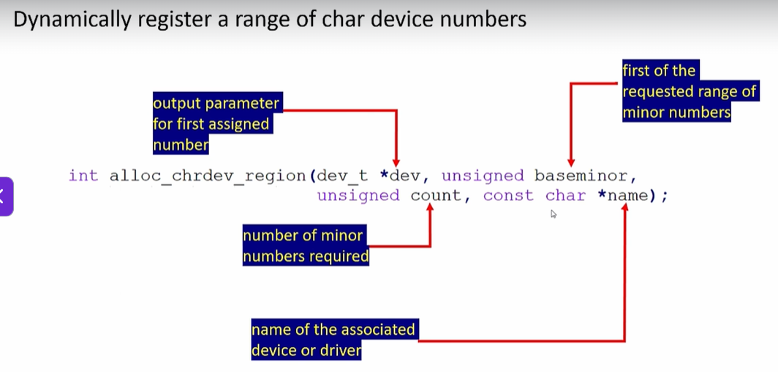

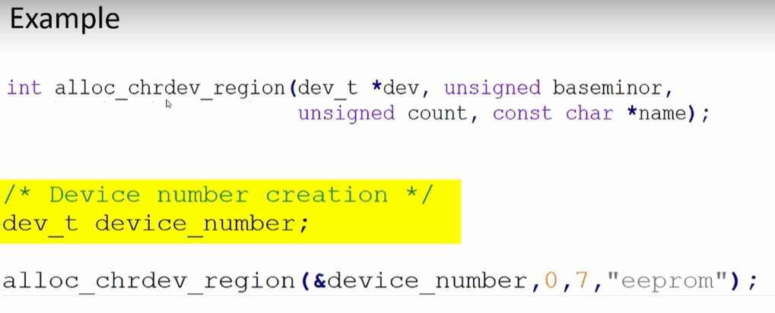
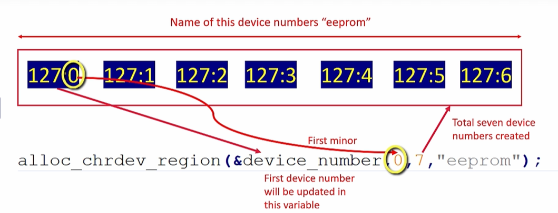
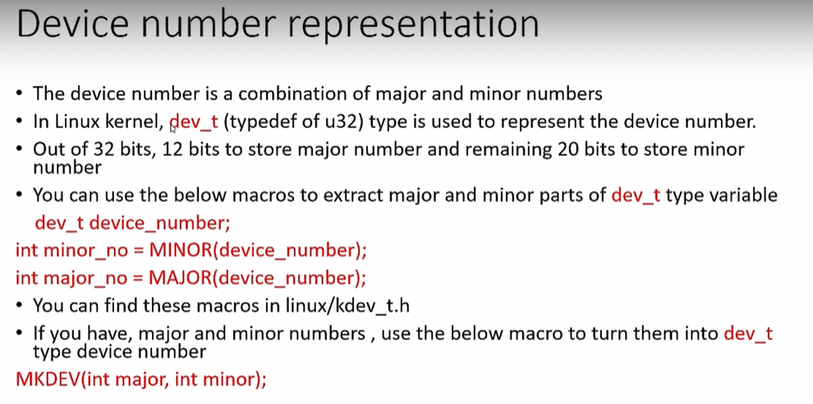

Character driver file operation method:
In this character driver we will give support to handle the below user level system calls
- open
- close
- read
- write
- llseek

